Business Unit
Mobile Failures Report
ASAP 7.0.2 – JAMU66

Week 32
August 06th to August 12th, 2018

August 13th, 2018

Contents

1 Percentages for all mobile activations, changes and deactivations Anguilla 4
2 Percentages for all mobile activations, changes and deactivations Antigua 5
3 Percentages for all mobile activations, changes and deactivations Barbados 6
4 Percentages for all mobile activations, changes and deactivations British Virgin Islands 7
5 Percentages for all mobile activations, changes and deactivations Cayman 8
6 Percentages for all mobile activations, changes and deactivations Dominica 9
7 Percentages for all mobile activations, changes and deactivations Grenada 10
8 Percentages for all mobile activations, changes and deactivations Jamaica 11
9 Percentages for all mobile activations, changes and deactivations Monserrat 12
10 Percentages for all mobile activations, changes and deactivations Saint Vincent 13
11 Percentages for all mobile activations, changes and deactivations Turks and Caicos 14
12 Percentages for all mobile activations, changes and deactivations Santa Lucia 15
13 Percentages for all mobile activations, changes and deactivations Saint Kitts and Nevis 16
14 Top 5 failure issues Anguilla 17
15 Top 5 failure issues Antigua 17
16 Top 5 failure issues Barbados 17
17 Top 5 failure issues British Virgin Islands 18
18 Top 5 failure issues Cayman 18
19 Top 5 failure issues Dominica 18
20 Top 5 failure issues Grenada 18
21 Top 5 failure issues Jamaica 19
22 Top 5 failure issues Monserrat 19
23 Top 5 failure issues Saint Vincent 19
24 Top 5 failure issues Turks and Caicos 19
25 Top 5 failure issues Santa Lucia 20
26 Top 5 failure issues Saint Kitts and Nevis 20
27 Failure numbers Anguilla 20
28 Failure numbers Antigua 20
29 Failure numbers Barbados 21
30 Failure numbers British Virgin Islands 23
31 Failure numbers Cayman 23
32 Failure numbers Dominica 24
33 Failure numbers Jamaica 24
34 Failure numbers Monserrat 26
35 Failure numbers Saint Vincent 26
36 Failure numbers Turks and Caicos 26
37 Failure numbers Santa Lucia 27
38 Failure numbers Saint Kitts and Nevis 28

Percentages for all mobile activations, changes and deactivations Anguilla

 | TOTAL | COMPLETE | FAILED | % Total | % COMPLETE | % FAILED
ACTIVATE | 6 | 6 | 0 | 6% | 100% | 0%
DEACTIVATE | 38 | 38 | 0 | 40% | 100% | 0%
MODIFY | 51 | 51 | 0 | 54% | 100% | 0%

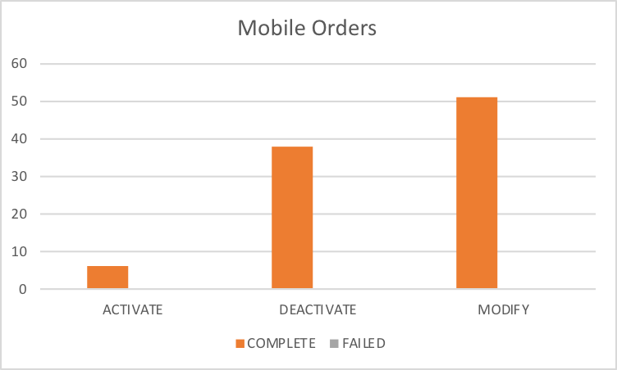

Percentages for all mobile activations, changes and deactivations Antigua

 | TOTAL | COMPLETE | FAILED | % Total | % COMPLETE | % FAILED
ACTIVATE | 46 | 29 | 17 | 7% | 63% | 37%
DEACTIVATE | 190 | 190 | 0 | 28% | 100% | 0%
MODIFY | 443 | 401 | 42 | 65% | 91% | 9%

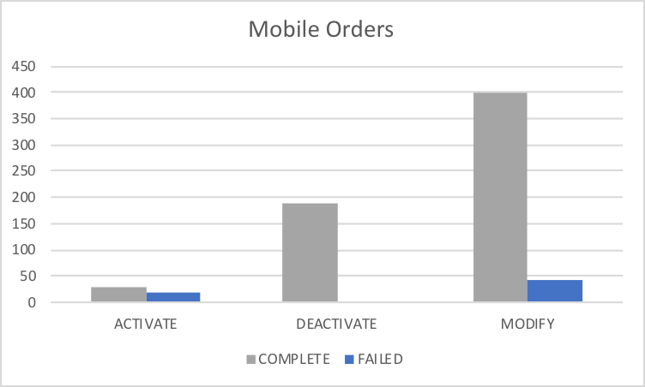

Percentages for all mobile activations, changes and deactivations Barbados

 | TOTAL | COMPLETE | FAILED | % Total | % COMPLETE | % FAILED
ACTIVATE | 36 | 8 | 28 | 3% | 22% | 78%
DEACTIVATE | 476 | 471 | 5 | 37% | 99% | 1%
MODIFY | 764 | 717 | 47 | 60% | 94% | 6%

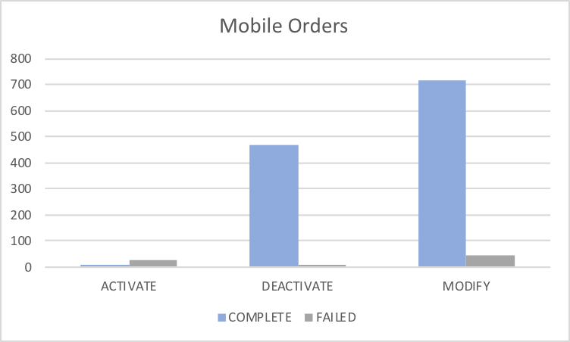

Percentages for all mobile activations, changes and deactivations British Virgin Islands

 | TOTAL | COMPLETE | FAILED | % Total | % COMPLETE | % FAILED
ACTIVATE | 80 | 80 | 0 | 14% | 100% | 0%
DEACTIVATE | 138 | 138 | 0 | 24% | 100% | 0%
MODIFY | 351 | 348 | 3 | 62% | 99% | 1%

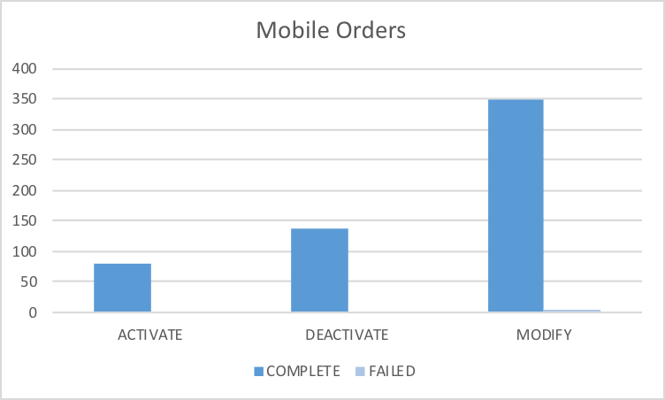

Percentages for all mobile activations, changes and deactivations Cayman

 | TOTAL | COMPLETE | FAILED | % Total | % COMPLETE | % FAILED
ACTIVATE | 44 | 40 | 4 | 8% | 91% | 9%
DEACTIVATE | 157 | 155 | 2 | 27% | 99% | 1%
MODIFY | 372 | 349 | 23 | 65% | 94% | 6%
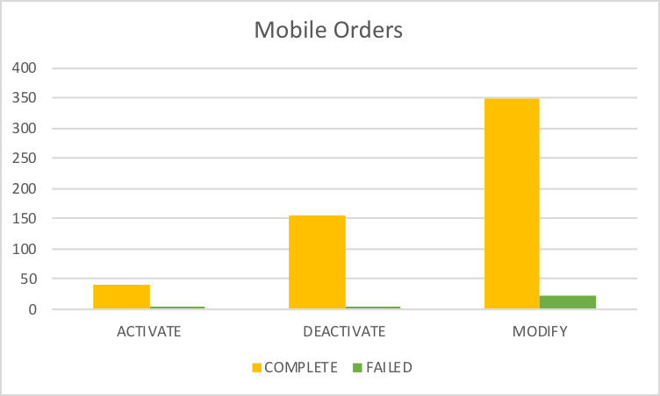

Percentages for all mobile activations, changes and deactivations Dominica

 | TOTAL | COMPLETE | FAILED | % Total | % COMPLETE | % FAILED
ACTIVATE | 25 | 21 | 4 | 1% | 84% | 16%
DEACTIVATE | 197 | 197 | 0 | 5% | 100% | 0%
MODIFY | 4154 | 4127 | 27 | 95% | 99% | 1%

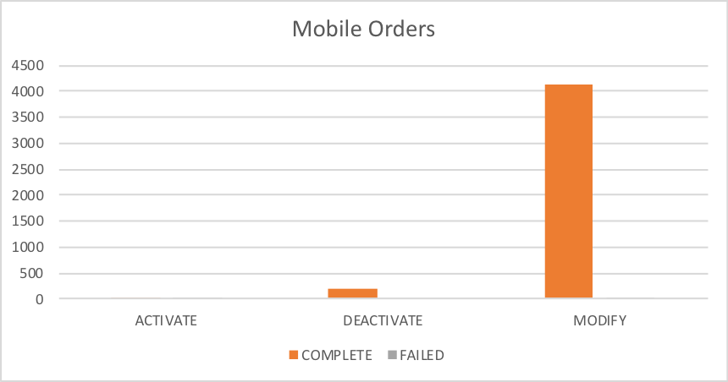

Percentages for all mobile activations, changes and deactivations Grenada

 | TOTAL | COMPLETE | FAILED | % Total | % COMPLETE | % FAILED
ACTIVATE | 94 | 94 | 0 | 12% | 100% | 0%
DEACTIVATE | 252 | 252 | 0 | 32% | 100% | 0%
MODIFY | 449 | 449 | 0 | 56% | 100% | 0%

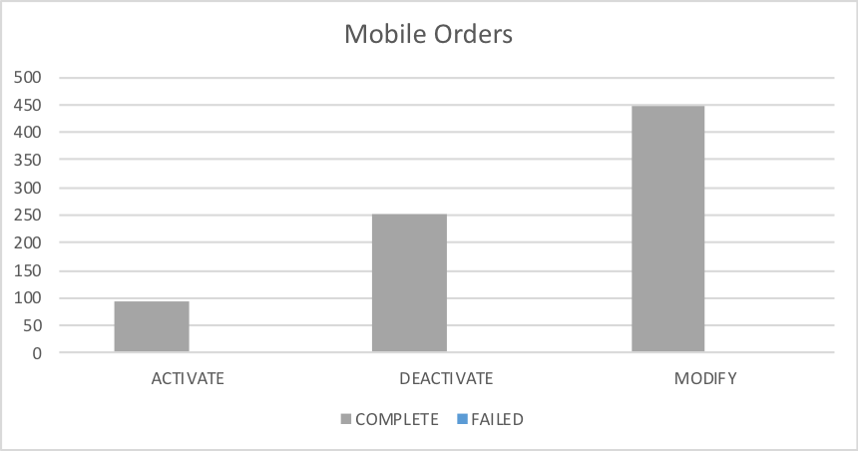

Percentages for all mobile activations, changes and deactivations Jamaica

 | TOTAL | COMPLETE | FAILED | % Total | % COMPLETE | % FAILED
ACTIVATE | 1629 | 1623 | 6 | 13% | 100% | 0%
DEACTIVATE | 3558 | 3553 | 5 | 27% | 100% | 0%
MODIFY | 7800 | 7766 | 34 | 60% | 100% | 0%

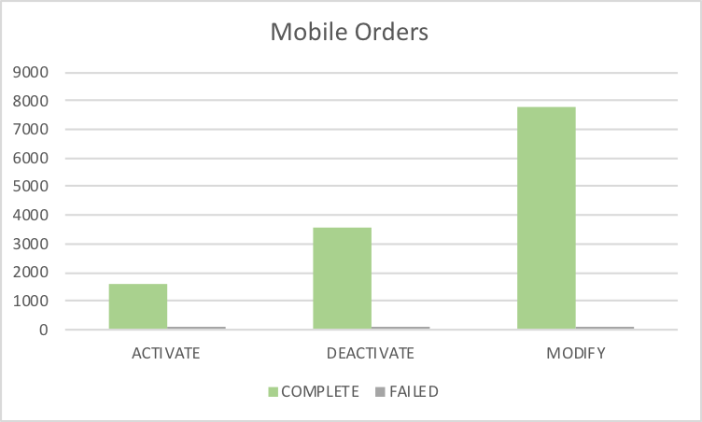

Percentages for all mobile activations, changes and deactivations Monserrat

 | TOTAL | COMPLETE | FAILED | % Total | % COMPLETE | % FAILED
ACTIVATE | 8 | 8 | 0 | 13% | 100% | 0%
DEACTIVATE | 13 | 13 | 0 | 21% | 100% | 0%
MODIFY | 41 | 41 | 0 | 66% | 100% | 0%

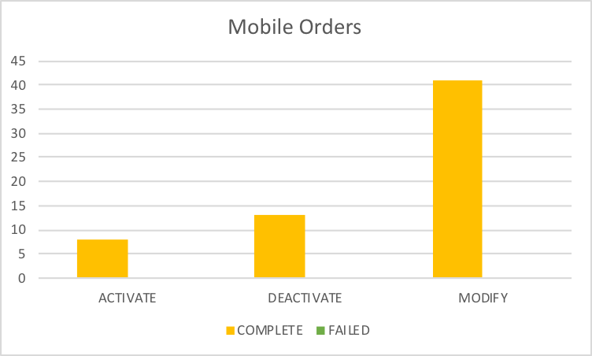

Percentages for all mobile activations, changes and deactivations Saint Vincent

 | TOTAL | COMPLETE | FAILED | % Total | % COMPLETE | % FAILED
ACTIVATE | 10 | 10 | 0 | 7% | 100% | 0%
DEACTIVATE | 17 | 17 | 0 | 13% | 100% | 0%
MODIFY | 108 | 108 | 0 | 80% | 100% | 0%

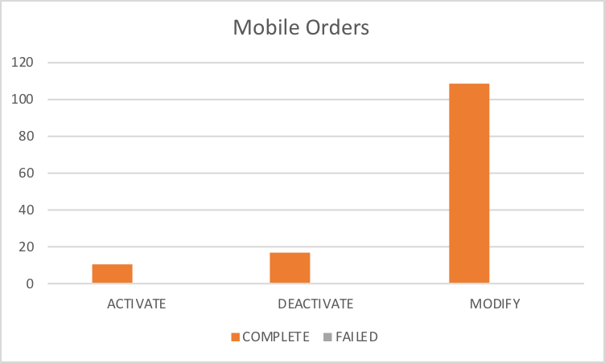

Percentages for all mobile activations, changes and deactivations Turks and Caicos

 | TOTAL | COMPLETE | FAILED | % Total | % COMPLETE | % FAILED
ACTIVATE | 56 | 49 | 7 | 16% | 88% | 13%
DEACTIVATE | 12 | 12 | 0 | 3% | 100% | 0%
MODIFY | 283 | 227 | 56 | 81% | 80% | 20%

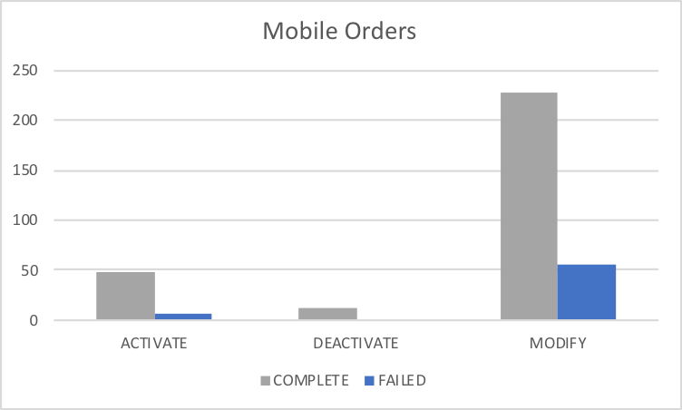

Percentages for all mobile activations, changes and deactivations Santa Lucia

 | TOTAL | COMPLETE | FAILED | % Total | % COMPLETE | % FAILED
ACTIVATE | 140 | 135 | 5 | 24% | 96% | 4%
DEACTIVATE | 15 | 15 | 0 | 3% | 100% | 0%
MODIFY | 430 | 420 | 10 | 74% | 98% | 2%

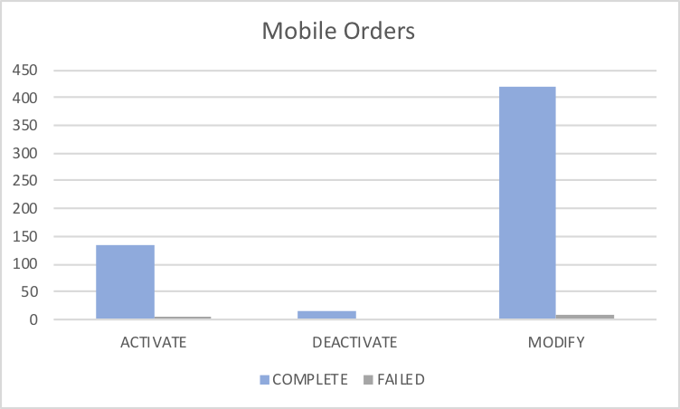

Percentages for all mobile activations, changes and deactivations Saint Kitts and Nevis

Column1 | TOTAL | COMPLETE | FAILED | % Total | % COMPLETE | % FAILED
ACTIVATE | 125 | 124 | 1 | 10% | 99% | 1%
DEACTIVATE | 184 | 184 | 0 | 15% | 100% | 0%
MODIFY | 921 | 919 | 2 | 75% | 100% | 0%

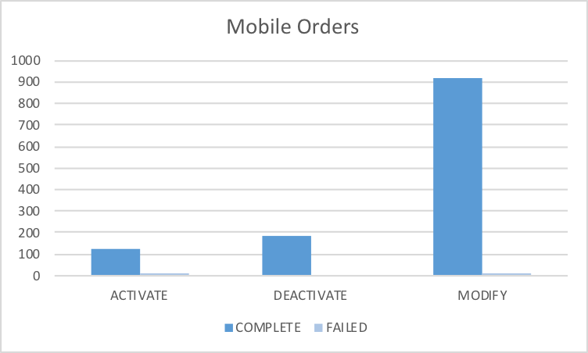

Top 5 failure issues Anguilla

No Rows Selected

Top 5 failure issues Antigua

30 | EMA_RESP_35101:Missing or invalid parameter.
5 | EMA_MISS_REQ_PARAM:Mandatory parameter is missing from work order
4 | EMA_RESP_1:The Specified IMSI is already defined
2 | EMA_RESP_35106:The subscriber does not exist.
1 | FAIL:No such object

Top 5 failure issues Barbados

14 | EMA_RESP_35101:Missing or invalid parameter.
9 | EMA_RESP_14:The Specified MSISDN is not defined
6 | NGVM_ETTY_DSNT_EXST:The specified Mailbox ID does not exist on the Comverse Voicemail platform.
5 | EMA_RESP_2:The Specified MSISDN is already defined with a different IMSI
5 | FAIL:No such object
3 | EMA_RESP_13:The Specified IMSI is not defined
3 | EMA_RESP_35105:The subscriber already exists.
1 | EMA_RESP_35106:The subscriber does not exist.
1 | EMA_RESP_3005:Invalid Argument or out of Range

Top 5 failure issues British Virgin Islands

2 | FAIL:No such object
1 | SAPC_PROVCARTEXP:The NE was denid due to provisioning cartridge exception

Top 5 failure issues Cayman

9 | EMA_RESP_35106:The subscriber does not exist.
5 | EMA_RESP_14:The Specified MSISDN is not defined
3 | EMA_RESP_2:The Specified MSISDN is already defined with a different IMSI
2 | MMS10_NO_UDET_MATCH:No User Defined Exit Type Found
2 | NGVM_ETTY_DSNT_EXST:The specified Mailbox ID does not exist on the Comverse Voicemail platform.
1 | EMA_RESP_35101:Missing or invalid parameter.
1 | EMA_RESP_35105:The subscriber already exists.

Top 5 failure issues Dominica

9 | EMA_RESP_14:The Specified MSISDN is not defined
7 | EMA_RESP_1:The Specified IMSI is already defined
5 | EMA_RESP_13:The Specified IMSI is not defined
3 | EMA_RESP_35101:Missing or invalid parameter.
2 | EMA_MISS_REQ_PARAM:Mandatory parameter is missing from work order
1 | EMA_RESP_35105:The subscriber already exists.

Top 5 failure issues Grenada

No Rows Selected

Top 5 failure issues Jamaica

8 | NGVM_ETTY_DSNT_EXST:The specified Mailbox ID does not exist on the Comverse Voicemail platform.
5 | FAIL:No such object
5 | EMA_MISS_REQ_PARAM:Mandatory parameter is missing from work order
5 | EMA_RESP_1:The Specified IMSI is already defined
4 | SAPC_PROVCARTEXP:The NE was denid due to provisioning cartridge exception
2 | SAPC_EXCEPTION:The NE was denid due to general exception
1 | EMA_RESP_35101:Missing or invalid parameter.
1 | EMA_RESP_6:Subscriber authentication data not found
1 | EMA_RESP_27:Operation not allowed due to interaction
1 | NGVM_SUBS_USED:The subscriber key (TelephoneNumber, ExternalSubscriberId, etc.) is already in use by another subscriber.
1 | EMA_RESP_1001:External system communication link failure.

Top 5 failure issues Monserrat

No Rows Selected

Top 5 failure issues Saint Vincent

No Rows Selected

Top 5 failure issues Turks and Caicos

37 | EMA_RESP_35106:The subscriber does not exist.
10 | EMA_RESP_35101:Missing or invalid parameter.
8 | EMA_RESP_1:The Specified IMSI is already defined
1 | EMA_RESP_14:The Specified MSISDN is not defined

Top 5 failure issues Santa Lucia

3 | EMA_RESP_35101:Missing or invalid parameter.
2 | EMA_RESP_2:The Specified MSISDN is already defined with a different IMSI
2 | EMA_RESP_1:The Specified IMSI is already defined
2 | EMA_MISS_REQ_PARAM:Mandatory parameter is missing from work order
1 | NGVM_ETTY_DSNT_EXST:The specified Mailbox ID does not exist on the Comverse Voicemail platform.

Top 5 failure issues Saint Kitts and Nevis

1 | EMA_RESP_35105:The subscriber already exists.
1 | SAPC_PROVCARTEXP:The NE was denid due to provisioning cartridge exception

Failure numbers Anguilla

No Rows Selected

Failure numbers Antigua
SRQ_ID | WO_ID | WO_STATUS | MSISDN
947312 | CIS:BAR:2992531:172.21.64.6:25009:1533732687379 | FAILED | 12687791615
947480 | CIS:BAR:2992546:172.21.64.6:25009:1533733986574 | FAILED | 12687726966
947585 | CIS:BAR:2992556:172.21.64.6:25009:1533734794008 | FAILED | 12687231921
947802 | CIS:BAR:2992576:172.21.64.6:25009:1533735722144 | FAILED | 12687796423
949289 | CIS:BAR:2992636:172.21.64.6:25009:1533740425422 | FAILED | 12687788389
949890 | CIS:BAR:2992685:172.21.64.6:25009:1533742995824 | FAILED | 12687704181
952986 | CIS:BAR:2992834:172.21.64.6:25009:1533755832060 | FAILED | 12687646315
953158 | CIS:BAR:2992856:172.21.64.6:25009:1533756756563 | FAILED | 12687793886
958411 | CIS:BAR:2993262:172.21.64.6:25009:1533824048200 | FAILED | 12687825352
969072 | CIS:BAR:2993656:172.21.64.6:25009:1533903000115 | FAILED | 12687726162
969431 | CIS:BAR:2993661:172.21.64.6:25009:1533906682587 | FAILED | 12687707109
969605 | CIS:BAR:2993684:172.21.64.6:25009:1533909503566 | FAILED | 12684641122
969778 | CIS:BAR:2993739:172.21.64.6:25009:1533911073100 | FAILED | 12687649286
969787 | CIS:BAR:2993742:172.21.64.6:25009:1533911217254 | FAILED | 12684640669
970191 | CIS:BAR:2993800:172.21.64.6:25009:1533914603424 | FAILED | 12684646804
970214 | CIS:BAR:2993805:172.21.64.6:25009:1533914766424 | FAILED | 12684646804
970244 | CIS:BAR:2993813:172.21.64.6:25009:1533914990286 | FAILED | 12684646804
970606 | CIS:BAR:2993871:172.21.64.6:25009:1533917393585 | FAILED | 12687721515
970749 | CIS:BAR:2993891:172.21.64.6:25009:1533918583276 | FAILED | 12687721515
970867 | CIS:BAR:2993908:172.21.64.6:25009:1533918894151 | FAILED | 12687236642
970930 | CIS:BAR:2993902:172.21.64.6:25009:1533919366756 | FAILED | 12687721515
970931 | CIS:BAR:2993910:172.21.64.6:25009:1533919380223 | FAILED | 12687645531
970937 | CIS:BAR:2993912:172.21.64.6:25009:1533919519567 | FAILED | 12687645531
970978 | CIS:BAR:2993919:172.21.64.6:25009:1533919790655 | FAILED | 12687645531
970980 | CIS:BAR:2993924:172.21.64.6:25009:1533919825437 | FAILED | 12687645531
971628 | CIS:BAR:2993998:172.21.64.6:25009:1533924425326 | FAILED | 12687706229
972362 | CIS:BAR:2994076:172.21.64.6:25009:1533929703093 | FAILED | 12684648134
972968 | CIS:BAR:2994146:172.21.64.6:25009:1533934203243 | FAILED | 12687787117
977095 | CIS:BAR:2994365:172.21.64.6:25009:1533992596082 | FAILED | 12687725306
977123 | CIS:BAR:2994379:172.21.64.6:25009:1533993378731 | FAILED | 12687761786
977201 | CIS:BAR:2994400:172.21.64.6:25009:1533995477821 | FAILED | 12684641122
977213 | CIS:BAR:2994411:172.21.64.6:25009:1533995891299 | FAILED | 12684641122
977911 | CIS:BAR:2994501:172.21.64.6:25009:1534005315875 | FAILED | 12687723222
977991 | CIS:BAR:2994510:172.21.64.6:25009:1534006303793 | FAILED | 12687761533
978222 | CIS:BAR:2994544:172.21.64.6:25009:1534009261083 | FAILED | 12684648720
978239 | CIS:BAR:2994557:172.21.64.6:25009:1534009419747 | FAILED | 12684648720
978302 | CIS:BAR:2994579:172.21.64.6:25009:1534010373545 | FAILED | 12687820959
978437 | CIS:BAR:2994586:172.21.64.6:25009:1534011401199 | FAILED | 12687820959
978517 | CIS:BAR:2994594:172.21.64.6:25009:1534012468197 | FAILED | 12687820959
978527 | CIS:BAR:2994600:172.21.64.6:25009:1534012665663 | FAILED | 12687820959
978571 | CIS:BAR:2994617:172.21.64.6:25009:1534013399388 | FAILED | 12687820959
978589 | CIS:BAR:2994628:172.21.64.6:25009:1534013658632 | FAILED | 12687820959

Failure numbers Barbados

SRQ_ID | WO_ID | WO_STATUS | MSISDN
938716 | CIS:BAR:23726651:172.21.64.13:25001:1533668317421 | FAILED | 12462302182
938736 | CIS:BAR:23726768:172.21.64.13:25001:1533668379318 | FAILED | 12462302182
949334 | OCA-5906 | FAILED | 12462308330
949349 | OCA-5907 | FAILED | 12462308330
949620 | OCA-5913 | FAILED | 12462308330
951706 | CIS:BAR:23752324:172.21.64.13:25001:1533751209868 | FAILED | 12462538646
953208 | CIS:BAR:23755297:172.21.64.13:25001:1533757080566 | FAILED | 12462503711
953277 | CIS:BAR:23755473:172.21.64.13:25001:1533757469835 | FAILED | 12462400558
953290 | CIS:BAR:23755514:172.21.64.13:25001:1533757540681 | FAILED | 12462400558
953319 | CIS:BAR:23755581:172.21.64.13:25001:1533757693634 | FAILED | 12462400558
953335 | CIS:BAR:23755617:172.21.64.13:25001:1533757789585 | FAILED | 12462400558
954116 | OCA-5938 | FAILED | 12462837305
954530 | OCA-5952 | FAILED | 12462837305
954570 | OCA-5954 | FAILED | 12462837305
958094 | CIS:BAR:23758358:172.21.64.13:25001:1533821108306 | FAILED | 12462400558
959626 | OCA-5957 | FAILED | 12462300165
964196 | CIS:BAR:23758431:172.21.64.13:25001:1533836702728 | FAILED | 12462503678
964472 | OCA-5980 | FAILED | 12462309589
964667 | OCA-5991 | FAILED | 12462306795
964668 | OCA-5992 | FAILED | 12462306795
964683 | OCA-5993 | FAILED | 12462306795
965561 | CIS:BAR:23758465:172.21.64.13:25001:1533845247530 | FAILED | 12462363260
965573 | CIS:BAR:23758470:172.21.64.13:25001:1533845296096 | FAILED | 12462363260
965754 | CIS:BAR:23758492:172.21.64.13:25001:1533846617122 | FAILED | 12462314424
969180 | CIS:BAR:23759260:172.21.64.13:25001:1533904983891 | FAILED | 12462340233
969184 | CIS:BAR:23759267:172.21.64.13:25001:1533905065080 | FAILED | 12462340233
969273 | CIS:BAR:23759269:172.21.64.13:25001:1533905175792 | FAILED | 12462340233
970223 | CIS:BAR:23759312:172.21.64.13:25001:1533914816446 | FAILED | 12462340233
970235 | CIS:BAR:23759317:172.21.64.13:25001:1533914934596 | FAILED | 12462340233
970425 | CIS:BAR:23759333:172.21.64.13:25001:1533916228063 | FAILED | 12462424759
971482 | OCA-6056 | FAILED | 12462434931
971699 | CIS:BAR:23759378:172.21.64.13:25001:1533925117747 | FAILED | 12462420791
971699 | CIS:BAR:23759378:172.21.64.13:25001:1533925117747 | FAILED | 12462513706
971703 | CIS:BAR:23759382:172.21.64.13:25001:1533925177769 | FAILED | 12462420791
971703 | CIS:BAR:23759382:172.21.64.13:25001:1533925177769 | FAILED | 12462513706
971731 | CIS:BAR:23759386:172.21.64.13:25001:1533925222840 | FAILED | 12462420791
971731 | CIS:BAR:23759386:172.21.64.13:25001:1533925222840 | FAILED | 12462513706
971766 | CIS:BAR:23759389:172.21.64.13:25001:1533925552068 | FAILED | 12462420791
971766 | CIS:BAR:23759389:172.21.64.13:25001:1533925552068 | FAILED | 12462513706
972131 | CIS:BAR:23759430:172.21.64.13:25001:1533928095828 | FAILED | 12462424759
972137 | CIS:BAR:23759440:172.21.64.13:25001:1533928171637 | FAILED | 12462424759
972223 | CIS:BAR:23759453:172.21.64.13:25001:1533929000821 | FAILED | 12462426450
972238 | CIS:BAR:23759460:172.21.64.13:25001:1533929179701 | FAILED | 12462420791
972238 | CIS:BAR:23759460:172.21.64.13:25001:1533929179701 | FAILED | 12462513706
973379 | OCA-6081 | FAILED | 12462301166
973759 | OCA-6084 | FAILED | 12462301166
973759 | OCA-6084 | FAILED | 12462337192
973810 | OCA-6085 | FAILED | 12462301166
973810 | OCA-6085 | FAILED | 12462301166
973836 | OCA-6086 | FAILED | 12462301166
973846 | OCA-6087 | FAILED | 12462301166
975073 | OCA-6090 | FAILED | 12462301166
975144 | OCA-6091 | FAILED | 12462301166
975144 | OCA-6091 | FAILED | 12462337192
975294 | OCA-6096 | FAILED | 12462301166

Failure numbers British Virgin Islands
SRQ_ID | WO_ID | WO_STATUS | MSISDN
963750 | CIS:BAR:2868295:172.21.64.3:25002:1533835000905 | FAILED | 12845426898
964879 | CIS:BAR:2868349:172.21.64.3:25002:1533841356857 | FAILED | 12845426143
977735 | CIS:BAR:2869119:172.21.64.3:25002:1534003463236 | FAILED | 12845425922

Failure numbers Cayman
SRQ_ID | WO_ID | WO_STATUS | MSISDN
925942 | CIS:CAY:6075416:172.21.64.16:25003:1533588243452 | FAILED | 13459290738
925946 | CIS:CAY:6075418:172.21.64.16:25003:1533588282451 | FAILED | 13459290738
925957 | CIS:CAY:6075434:172.21.64.16:25003:1533588733991 | FAILED | 13459290738
931998 | CIS:CAY:6075726:172.21.64.16:25003:1533647673697 | FAILED | 13459296704
937112 | CIS:CAY:6075939:172.21.64.16:25003:1533662449748 | FAILED | 13459383567
937980 | CIS:CAY:6075988:172.21.64.16:25003:1533665284473 | FAILED | 13459266752
940719 | CIS:CAY:6076198:172.21.64.16:25003:1533675782663 | FAILED | 13459161349
944316 | CIS:CAY:6076345:172.21.64.16:25003:1533720180185 | FAILED | 13459298148
951475 | CIS:CAY:6076762:172.21.64.16:25003:1533750070333 | FAILED | 13459258565
953871 | CIS:CAY:6076895:172.21.64.16:25003:1533760262872 | FAILED | 13459390089
953959 | CIS:CAY:6076898:172.21.64.16:25003:1533760360709 | FAILED | 13459390089
954760 | CIS:CAY:6076990:172.21.64.16:25003:1533764642941 | FAILED | 13459250031
962924 | CIS:CAY:6077255:172.21.64.16:25003:1533830525241 | FAILED | 13459258620
970128 | CIS:CAY:6077860:172.21.64.16:25003:1533914053003 | FAILED | 13459166773
970453 | CIS:CAY:6077926:172.21.64.16:25003:1533916559840 | FAILED | 13459258623
973219 | CIS:CAY:6078205:172.21.64.16:25003:1533936101632 | FAILED | 13459160507
973259 | CIS:CAY:6078223:172.21.64.16:25003:1533936585360 | FAILED | 13459160507
973409 | CIS:CAY:6078236:172.21.64.16:25003:1533937381763 | FAILED | 13459160507
977753 | CIS:CAY:6078564:172.21.64.16:25003:1534003699628 | FAILED | 13459258654
977766 | CIS:CAY:6078566:172.21.64.16:25003:1534003818362 | FAILED | 13459258654
980104 | CIS:CAY:6078864:172.21.64.16:25003:1534065877223 | FAILED | 13459297696
981574 | CIS:CAY:6079023:172.21.64.16:25003:1534103841805 | FAILED | 13459292514
981575 | CIS:CAY:6079024:172.21.64.16:25003:1534103897798 | FAILED | 13459292514

Failure numbers Dominica
SRQ_ID | WO_ID | WO_STATUS | MSISDN
938928 | CIS:BAR:4151681:172.21.64.4:25008:1533669029684 | FAILED | 17672353666
938939 | CIS:BAR:4151683:172.21.64.4:25008:1533669095531 | FAILED | 17672353666
938948 | CIS:BAR:4151684:172.21.64.4:25008:1533669155050 | FAILED | 17672353666
939329 | CIS:BAR:4151736:172.21.64.4:25008:1533670518110 | FAILED | 17672253734
947403 | CIS:BAR:4152025:172.21.64.4:25008:1533733450600 | FAILED | 17672758170
958067 | CIS:BAR:4152791:172.21.64.4:25008:1533820697620 | FAILED | 17672450010
958083 | CIS:BAR:4152796:172.21.64.4:25008:1533820891317 | FAILED | 17672450010
958087 | CIS:BAR:4152797:172.21.64.4:25008:1533820994050 | FAILED | 17672450010
958092 | CIS:BAR:4152798:172.21.64.4:25008:1533821097780 | FAILED | 17672450010
958149 | CIS:BAR:4152810:172.21.64.4:25008:1533821713446 | FAILED | 17672450010
958174 | CIS:BAR:4152819:172.21.64.4:25008:1533821974570 | FAILED | 17672450010
958412 | CIS:BAR:4152866:172.21.64.4:25008:1533824060699 | FAILED | 17672450010
959674 | CIS:BAR:4210562:172.21.64.4:25008:1533824937287 | FAILED | 17672450010
959913 | CIS:BAR:4210783:172.21.64.4:25008:1533825073494 | FAILED | 17672450010
960928 | CIS:BAR:4212321:172.21.64.4:25008:1533825708108 | FAILED | 17672252168
961260 | CIS:BAR:4213245:172.21.64.4:25008:1533825915221 | FAILED | 17672253628
961415 | CIS:BAR:4213665:172.21.64.4:25008:1533826011343 | FAILED | 17672254114
961595 | CIS:BAR:4214154:172.21.64.4:25008:1533826124853 | FAILED | 17672254913
969371 | CIS:BAR:4271664:172.21.64.4:25008:1533906118675 | FAILED | 17672255853
969377 | CIS:BAR:4271675:172.21.64.4:25008:1533906161563 | FAILED | 17672651145
970123 | CIS:BAR:4272155:172.21.64.4:25008:1533914014972 | FAILED | 17672652920
970138 | CIS:BAR:4272161:172.21.64.4:25008:1533914139826 | FAILED | 17672652920
970140 | CIS:BAR:4272163:172.21.64.4:25008:1533914180452 | FAILED | 17672652920
970148 | CIS:BAR:4272164:172.21.64.4:25008:1533914249352 | FAILED | 17672652920
977645 | CIS:BAR:4273289:172.21.64.4:25008:1534002614321 | FAILED | 17672769822
978143 | CIS:BAR:4273418:172.21.64.4:25008:1534008167109 | FAILED | 17672766628
978205 | CIS:BAR:4273441:172.21.64.4:25008:1534009071826 | FAILED | 17672952229

Failure numbers Jamaica

SRQ_ID | WO_ID | WO_STATUS | MSISDN
925371 | CIS:JAM:185264354:172.21.64.17:25007:1533566949641 | FAILED | 18765090248
925408 | CIS:JAM:185264429:172.21.64.17:25007:1533568204605 | FAILED | 18769097457
925416 | CIS:JAM:185264446:172.21.64.17:25007:1533568634920 | FAILED | 18765409926
925599 | CIS:JAM:185264773:172.21.64.17:25007:1533575053433 | FAILED | 18765359922
925679 | CIS:JAM:185264929:172.21.64.17:25007:1533577980136 | FAILED | 18764794450
930735 | CIS:JAM:185308310:172.21.64.17:25007:1533642459149 | FAILED | 18769971624
933254 | CIS:JAM:185309009:172.21.64.17:25007:1533650456510 | FAILED | 18768226735
933254 | CIS:JAM:185309009:172.21.64.17:25007:1533650456510 | FAILED | 18768342296
933790 | CIS:JAM:185309690:172.21.64.17:25007:1533652153365 | FAILED | 18769197714
943860 | CIS:JAM:185332407:172.21.64.17:25007:1533694282202 | FAILED | 18768312789
943861 | CIS:JAM:185332409:172.21.64.17:25007:1533694335009 | FAILED | 18768312789
951138 | CIS:JAM:185384896:172.21.64.17:25007:1533748311191 | FAILED | 18767743890
952452 | CIS:JAM:185387448:172.21.64.17:25007:1533753429936 | FAILED | 18768035355
953775 | CIS:JAM:185389868:172.21.64.17:25007:1533759955118 | FAILED | 18767826843
953799 | CIS:JAM:185389919:172.21.64.17:25007:1533760096993 | FAILED | 18768279237
954303 | CIS:JAM:185391056:172.21.64.17:25007:1533761597211 | FAILED | 18767717079
954312 | CIS:JAM:185391077:172.21.64.17:25007:1533761656684 | FAILED | 18767717079
955013 | CIS:JAM:185393398:172.21.64.17:25007:1533768520248 | FAILED | 18763224854
964522 | CIS:JAM:185475077:172.21.64.17:25007:1533838966161 | FAILED | 18767970991
965281 | CIS:JAM:185477928:172.21.64.17:25007:1533843596999 | FAILED | 18765329276
966562 | CIS:JAM:185482211:172.21.64.17:25007:1533852785968 | FAILED | 18763278694
966565 | CIS:JAM:185482217:172.21.64.17:25007:1533852872860 | FAILED | 18763278694
970220 | CIS:JAM:185494498:172.21.64.17:25007:1533914804163 | FAILED | 18763261873
971751 | CIS:JAM:185498199:172.21.64.17:25007:1533925392263 | FAILED | 18768200517
972093 | CIS:JAM:185498948:172.21.64.17:25007:1533927714897 | FAILED | 18767752550
977456 | CIS:JAM:185520642:172.21.64.17:25007:1534000510779 | FAILED | 18769090027
977456 | CIS:JAM:185520642:172.21.64.17:25007:1534000510779 | FAILED | 18769090566
977466 | CIS:JAM:185520675:172.21.64.17:25007:1534000574786 | FAILED | 18769090027
977466 | CIS:JAM:185520675:172.21.64.17:25007:1534000574786 | FAILED | 18769090566
977474 | CIS:JAM:185520695:172.21.64.17:25007:1534000711978 | FAILED | 18769090027
977474 | CIS:JAM:185520695:172.21.64.17:25007:1534000711978 | FAILED | 18769090566
977487 | CIS:JAM:185520719:172.21.64.17:25007:1534000892438 | FAILED | 18769090027
977487 | CIS:JAM:185520719:172.21.64.17:25007:1534000892438 | FAILED | 18769090566
978790 | CIS:JAM:185524137:172.21.64.17:25007:1534017319416 | FAILED | 18768336447
979178 | CIS:JAM:185525479:172.21.64.17:25007:1534025242752 | FAILED | 18763277781
979703 | CIS:JAM:185526997:172.21.64.17:25007:1534037084757 | FAILED | 18765440978
979706 | CIS:JAM:185527003:172.21.64.17:25007:1534037170349 | FAILED | 18765440978
981375 | CIS:JAM:185628028:172.21.64.17:25007:1534084733387 | FAILED | 18763278694
981516 | CIS:JAM:185628593:172.21.64.17:25007:1534096930337 | FAILED | 18763106093

Failure numbers Monserrat

No Rows Selected

Failure numbers Saint Vincent

No Rows Selected

Failure numbers Turks and Caicos

SRQ_ID | WO_ID | WO_STATUS | MSISDN
931668 | CIS:BAR:2470616:172.21.64.5:25007:1533646651960 | FAILED | 16492419320
932163 | CIS:BAR:2470629:172.21.64.5:25007:1533648223362 | FAILED | 16492316852
933819 | CIS:BAR:2470741:172.21.64.5:25007:1533652238416 | FAILED | 16492439371
934159 | CIS:BAR:2470806:172.21.64.5:25007:1533653204332 | FAILED | 16492420209
934580 | CIS:BAR:2470815:172.21.64.5:25007:1533654385851 | FAILED | 16492414948
934917 | CIS:BAR:2470872:172.21.64.5:25007:1533655093545 | FAILED | 16492457497
935522 | CIS:BAR:2470947:172.21.64.5:25007:1533657157802 | FAILED | 16492312366
935534 | CIS:BAR:2470949:172.21.64.5:25007:1533657195026 | FAILED | 16492312366
936089 | CIS:BAR:2470980:172.21.64.5:25007:1533658947741 | FAILED | 16494318069
939489 | CIS:BAR:2471191:172.21.64.5:25007:1533671263901 | FAILED | 16492324952
939496 | CIS:BAR:2471192:172.21.64.5:25007:1533671289025 | FAILED | 16492418560
939621 | CIS:BAR:2471199:172.21.64.5:25007:1533671925769 | FAILED | 16492327124
939643 | CIS:BAR:2471204:172.21.64.5:25007:1533672013741 | FAILED | 16492327124
939745 | CIS:BAR:2471206:172.21.64.5:25007:1533672149387 | FAILED | 16492424067
939914 | CIS:BAR:2471214:172.21.64.5:25007:1533672649747 | FAILED | 16492424067
940004 | CIS:BAR:2471224:172.21.64.5:25007:1533673033602 | FAILED | 16492463109
940037 | CIS:BAR:2471228:172.21.64.5:25007:1533673155602 | FAILED | 16492463109
947837 | CIS:BAR:2471653:172.21.64.5:25007:1533735983877 | FAILED | 16494329488
949266 | CIS:BAR:2475674:172.21.64.5:25007:1533740403754 | FAILED | 16492423706
949836 | CIS:BAR:2476252:172.21.64.5:25007:1533742757985 | FAILED | 16492427811
950505 | CIS:BAR:2476537:172.21.64.5:25007:1533745826962 | FAILED | 16492473577
954328 | CIS:BAR:2477112:172.21.64.5:25007:1533761719913 | FAILED | 16492476114
954333 | CIS:BAR:2477114:172.21.64.5:25007:1533761759381 | FAILED | 16492476114
954505 | CIS:BAR:2477155:172.21.64.5:25007:1533762687380 | FAILED | 16492437444
954896 | CIS:BAR:2477188:172.21.64.5:25007:1533766488201 | FAILED | 16492431528
955004 | CIS:BAR:2477199:172.21.64.5:25007:1533768412020 | FAILED | 16492457034
958130 | CIS:BAR:2477324:172.21.64.5:25007:1533821543506 | FAILED | 16492462820
958304 | CIS:BAR:2477504:172.21.64.5:25007:1533823125206 | FAILED | 16492450411
962276 | CIS:BAR:2477655:172.21.64.5:25007:1533826704331 | FAILED | 16492423509
962531 | CIS:BAR:2477723:172.21.64.5:25007:1533828172140 | FAILED | 16492411496
962762 | CIS:BAR:2477759:172.21.64.5:25007:1533829614313 | FAILED | 16492447425
963177 | CIS:BAR:2477795:172.21.64.5:25007:1533832312433 | FAILED | 16492329585
963213 | CIS:BAR:2477798:172.21.64.5:25007:1533832380851 | FAILED | 16492461417
963982 | CIS:BAR:2477912:172.21.64.5:25007:1533835690505 | FAILED | 16492430512
964101 | CIS:BAR:2477920:172.21.64.5:25007:1533835968300 | FAILED | 16492430512
964422 | CIS:BAR:2477983:172.21.64.5:25007:1533838241610 | FAILED | 16492430030
964630 | CIS:BAR:2478081:172.21.64.5:25007:1533839767079 | FAILED | 16492418838
969556 | CIS:BAR:2478307:172.21.64.5:25007:1533908706672 | FAILED | 16492426124
969620 | CIS:BAR:2478345:172.21.64.5:25007:1533909721512 | FAILED | 16492421035
969629 | CIS:BAR:2478350:172.21.64.5:25007:1533909792903 | FAILED | 16492322175
969636 | CIS:BAR:2478352:172.21.64.5:25007:1533909902693 | FAILED | 16492322175
969719 | CIS:BAR:2478364:172.21.64.5:25007:1533910576109 | FAILED | 16492445074
970543 | CIS:BAR:2478489:172.21.64.5:25007:1533916958352 | FAILED | 16492328841
970730 | CIS:BAR:2478514:172.21.64.5:25007:1533918416409 | FAILED | 16492444660
970952 | CIS:BAR:2478532:172.21.64.5:25007:1533919598418 | FAILED | 16492444210
971137 | CIS:BAR:2478560:172.21.64.5:25007:1533921128028 | FAILED | 16492462128
971334 | CIS:BAR:2478587:172.21.64.5:25007:1533922518088 | FAILED | 16492320088
971341 | CIS:BAR:2478589:172.21.64.5:25007:1533922563934 | FAILED | 16492320088
972049 | CIS:BAR:2478745:172.21.64.5:25007:1533927530954 | FAILED | 16492317246
972100 | CIS:BAR:2478751:172.21.64.5:25007:1533927781095 | FAILED | 16492317246
972127 | CIS:BAR:2478754:172.21.64.5:25007:1533928049797 | FAILED | 16492317246
972198 | CIS:BAR:2478756:172.21.64.5:25007:1533928778778 | FAILED | 16492317246
973126 | CIS:BAR:2478777:172.21.64.5:25007:1533935341675 | FAILED | 16492466677
977928 | CIS:BAR:2478863:172.21.64.5:25007:1534005382301 | FAILED | 16492418322
977975 | CIS:BAR:2478869:172.21.64.5:25007:1534006080795 | FAILED | 16492418497
979117 | CIS:BAR:2478933:172.21.64.5:25007:1534023865167 | FAILED | 16492424039

Failure numbers Santa Lucia
SRQ_ID | WO_ID | WO_STATUS | MSISDN
925194 | CIS:BAR:7901955:172.21.64.99:25011:1533559026985 | FAILED | 17582851553
925566 | CIS:BAR:8565776:172.21.64.7:25011:1533573992590 | FAILED | 17582879681
925568 | CIS:BAR:8565785:172.21.64.7:25011:1533574040270 | FAILED | 17582879681
961939 | CIS:BAR:8580829:172.21.64.7:25011:1533826335785 | FAILED | 17582842070
963321 | CIS:BAR:7901980:172.21.64.99:25011:1533832949263 | FAILED | 17584853650
965128 | CIS:SOU:8581698:172.21.64.7:25011:1533842859060 | FAILED | 17582840559
965868 | CIS:BAR:8581891:172.21.64.7:25011:1533847332753 | FAILED | 17585847799
965874 | CIS:BAR:8581893:172.21.64.7:25011:1533847378874 | FAILED | 17585847799
969279 | CIS:BAR:8582377:172.21.64.7:25011:1533905286722 | FAILED | 17584611568
969281 | CIS:BAR:8582379:172.21.64.7:25011:1533905371520 | FAILED | 17584611568

Failure numbers Saint Kitts and Nevis

SRQ_ID | WO_ID | WO_STATUS | MSISDN
951474 | CIS:BAR:3649564:172.21.64.12:25006:1533750068560 | FAILED | 18696623170
962858 | CIS:BAR:3650357:172.21.64.12:25006:1533830352908 | FAILED | 18696607976

